**Sample 1**: the pristine polymer material

**Sample 2**: the physical mixture of pristine polymer material and sulfur. Principally, the structure keep unchanged.

**Sample 3**: the mixture of pristine polymer material and sulfur under high temperature. The structure already changed. The possible structure is

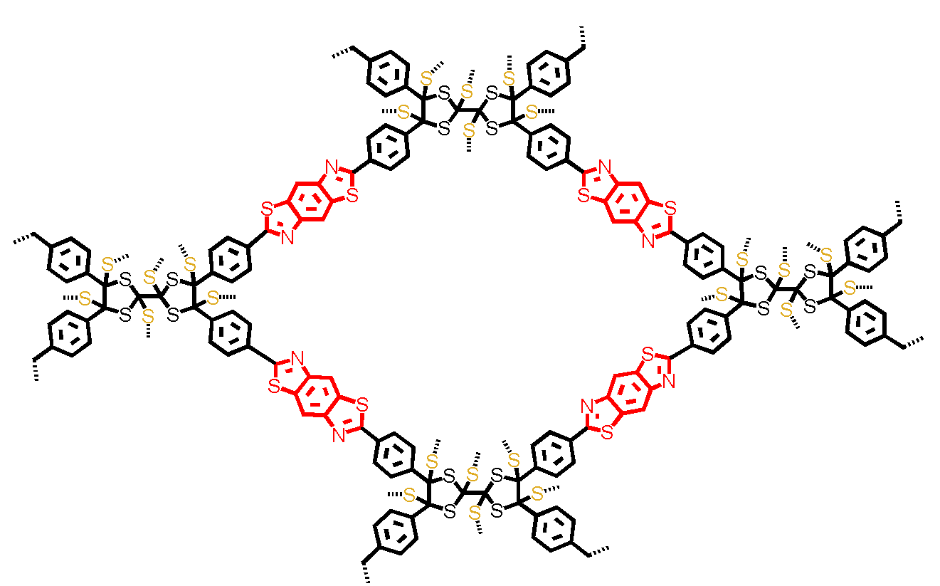

**Sample 4**: the same one as sample 3, while the excess sulfur is removed.

